Morning December 10, 2020 Livestock Report
by Chris Lehner | 312.242.7942 | chris.lehner@admis.com

CATTLE
USDA FEDERAL CATTLE SLAUGHTER

DECEMBER 09, 2020 120,000
WEEK AGO 120,000
YEAR AGO 124,000
WEEK TO DATE (EST) 354,000
SAME PERIOD LAST WEEK (EST) 361,000
SAME PERIOD LAST YEAR (ACT ) 369,000

=============
CHOICE SELECT
BOXED BEEF FINAL 218.26 201.65
CHANGE FROM PRIOR DAY (6.76) (3.77)
CHOICE/SELECT SPREAD: 16.61
TOTAL LOAD COUNT 207
5 DAY SIMPLE AVERAGE: 234.18 215.06

==================
Based on negotiated prices and volume of boxed beef cuts delivered within 0-21 days and on average industry cutting yields. Values reflect U.S. dollars per 100 pounds

FINAL DECEMBER 09, 2020
Primal Rib 479.92 387.69
Primal Chuck 171.79 164.37
Primal Round 169.75 170.22
Primal Loin 263.87 244.53
Primal Brisket 143.56 146.53
Primal Short Plate 118.08 118.08
Primal Flank 95.09 94.14

LOAD COUNT AND CUTOUT VALUE SUMMARY FOR PRIOR 8 DAYS
CHOICE SELECT
Date Choice Select Trim Grinds Total 600-900 600-900
12/08 122 39 39 29 228 225.02 205.42
12/07 112 27 7 16 161 230.80 209.48
12/04 81 19 15 16 132 235.02 217.51
12/03 131 15 20 22 189 239.19 219.93
12/02 74 12 18 19 123 240.89 222.95
12/01 78 13 11 27 130 243.40 223.08
11/30 53 12 12 7 84 243.68 222.43
11/27 30 7 8 7 51 242.85 220.68

==========================================
NATIONAL BOXED BEEF CUTS - NEGOTIATED SALES FOB Plant basis negotiated sales for delivery within 0-21-day period. Prior days sales after 1:30pm are included.
CURRENT VOLUME - (one load equals 40,000 pounds)

Choice Cuts 132.29 loads 5,291,576 pounds
Select Cuts 39.73 loads 1,589,030 pounds
Trimmings 16.53 loads 661,313 pounds
Ground Beef 18.43 loads 737,066 pounds
======================================

USDA BY-PRODUCT DROP VALUE (STEER) FOB CENTRAL U.S.
HTTPS://WWW.AMS.USDA.GOV/MNREPORTS/NW_LS441.TXT

BEEF AND PORK EXPORTS ON LAST PAGE OF REPORT

DECEMBER 2020 USDA LIVESTOCK REPORTS
USDA CATTLE ON FEED – FRIDAY DECEMBER 18, 2020 2:00PM CENTRAL TIME
USDA COLD STORAGE – TUESDAY DECEMBER 22, 2020 2:00PM CENTRAL TIME
USDA QUARTERLY HOGS AND PIGS– WEDNESDAY DECEMBER 23, 2020 2:00PM CENTRAL TIME
===========================
DELIVERY NOTICE SERVED – DECEMBER 2020 - LIVE CATTLE
SETTLEMENT: DECEMBER 9, 2020 - $107.37
OLDEST LONG: 02/28/20 SETTLEMENT AT $117.77
0 DELIVERIES

===================
USDA POSTED CATTLE PRICES ON 12/09/2020
IA/MN – CASH - 103.00 - 107.00 Dressed.- 165.00 - 168.00
NE - CASH – 105.00 - 107.00 Dressed.- 168.00
KS – CASH No Reportable Trade. Dressed - No Reportable Trade.
TX/OK/NM – 108.00
CO – Information not available due to confidentiality

***National Daily Direct Cattle 12/04/2020
(5 day accumulated weighted avg)
Weight Price Head
Live Steer: 1477 $109.41 38,647
Live Heifer: 1304 $109.54 18,220
Dressed Steer: 983 $171.70 13,910
Dressed Heifer: 875 $172.17 5,233

===============
Boxed beef falling on 228 loads with 132 loads of Choice beef down 6.76. With 228 loads the largest movement over past 8 days, it looks as though packers are not only selling beef lower but dumping it. It may mean packers have fewer contracted beef needed and are using daily market to clean up what isn’t needed in contracted beef.
========================
Beef export net sales are pathetic. Only 3000 metric tonnes for 2020 and 6400 metric tonnes for 2021.

With the cheap US Dollar, US beef should be flying out the door.
===============================

As of December 8, 2020, dressed steer and heifer weights were 894.2 compared to previous week at 896.5 down 2.3 pounds from week ago and the same as last week, 21 pounds over a year ago. Grading percent was 81.9%, down compared to previous week at 81.9 %.

===========================

FEBRUARY 2021 LIVE CATTLE/APRIL 2021 LIVE CATTLE SPREAD - Spread widening is bearish.
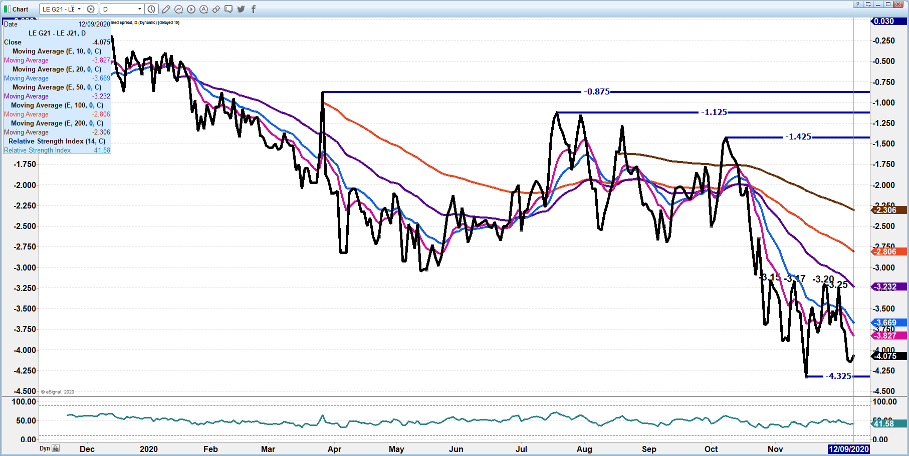
DECEMBER 2020 LIVE CATTLE - 106.60 next support. No deliveries on December Resistance at 109.32
- 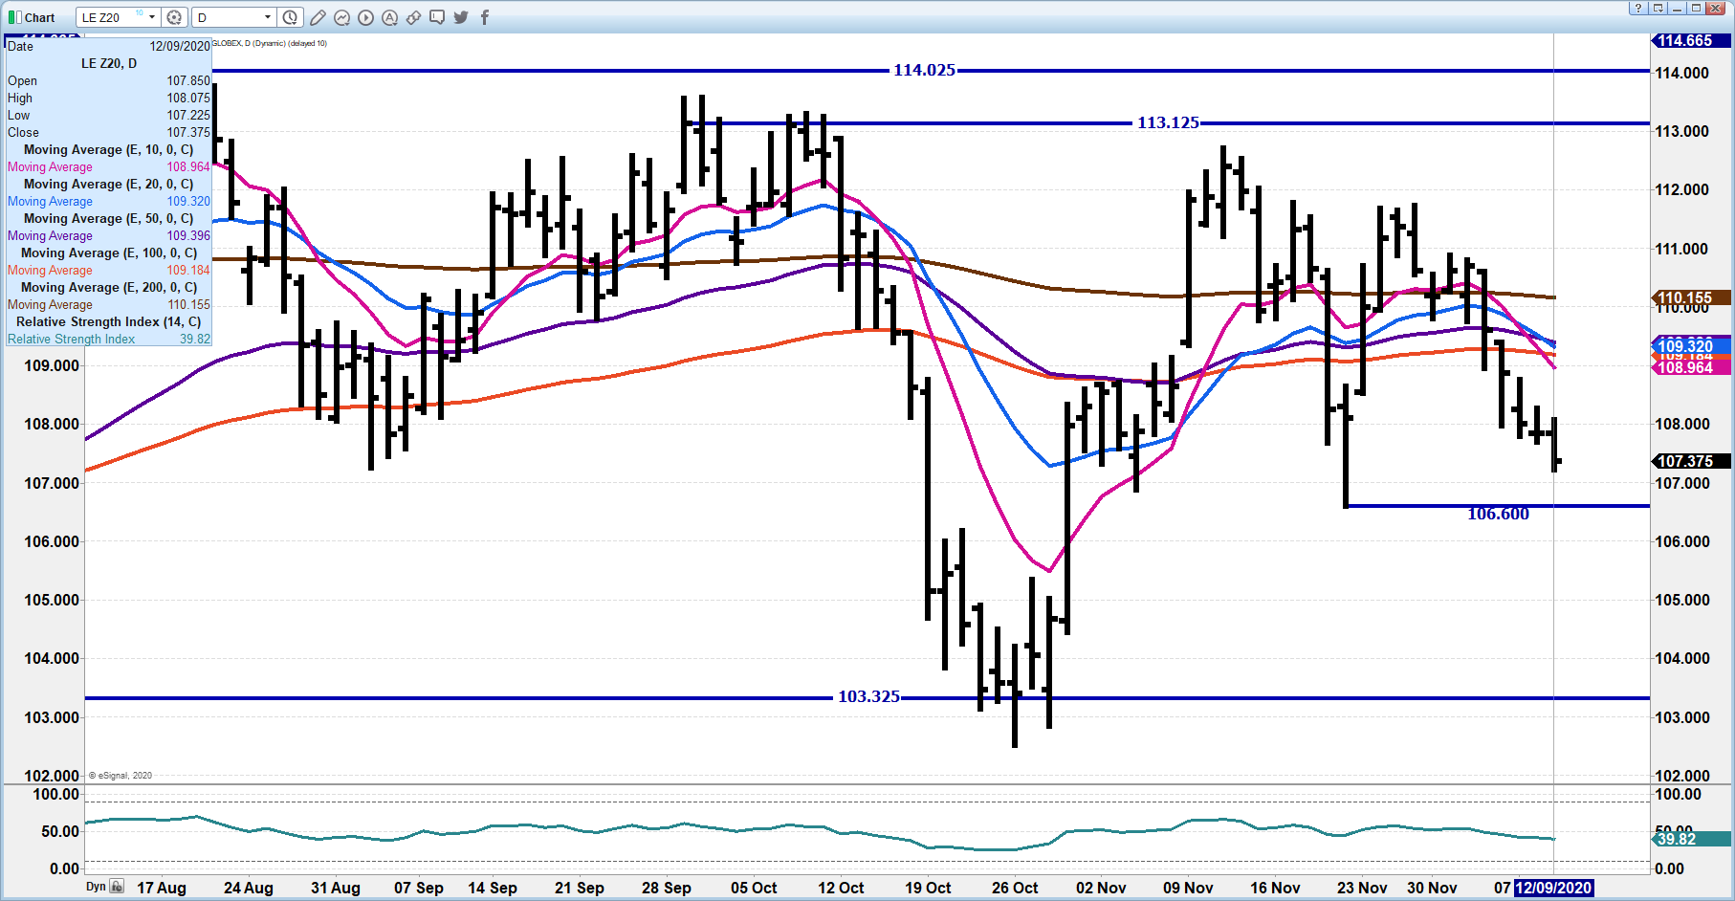

FEBRUARY 2021 LIVE CATTLE – Resistance 112.02 Support at 109.00 Volume at 15,620
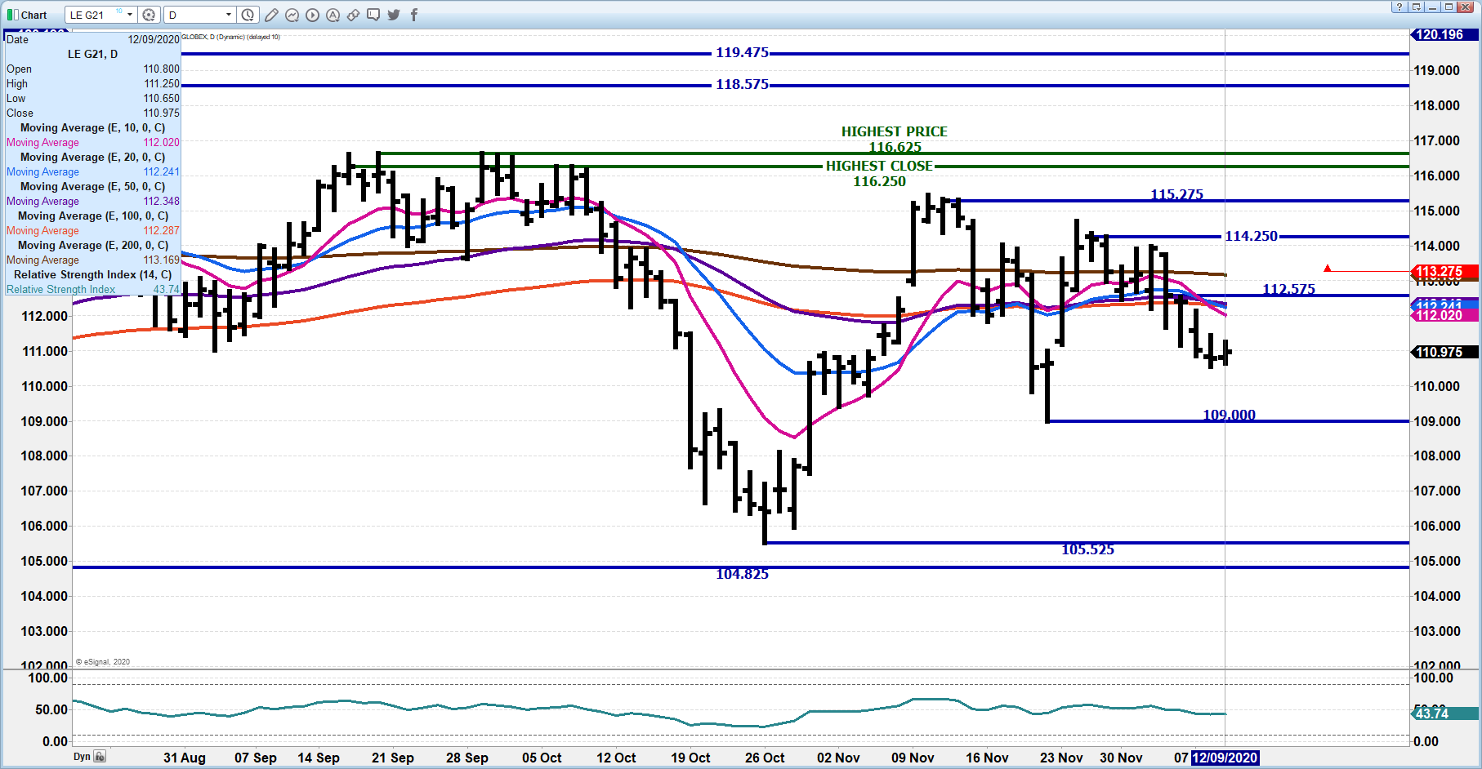
APRIL 2021 LIVE CATTLE - Volume 9,320 Support at 113.22 Resistance at 115.05 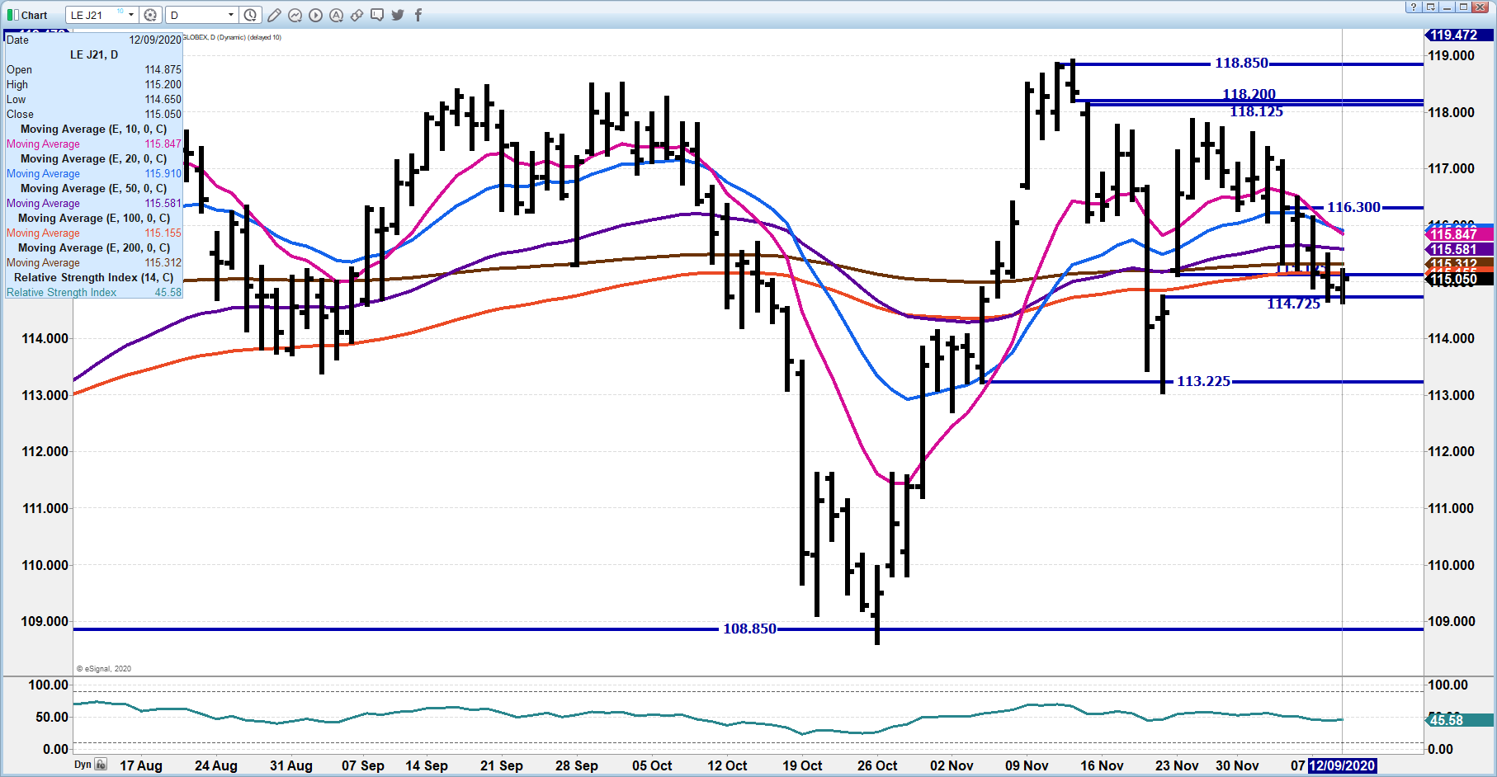
Feeder Cattle

THE CME FEEDER INDEX ON 12/08/2020 waS 137.20 down 14 cents from previous daY -

JANUARY 2021 FEEDER CATTLE FUTURES SETTLED ON DECEMBER 09, 2020 AT $138.80
=============================
NATIONAL FEEDER & STOCKER SUMMARY - WEEK ENDING 12/04/2020

RECEIPTS: Auctions Direct Video/Internet Total
This Week: 278,600 34,500 60,000 373,100
Last Week: 112,300 35,300 1,600 149,200
Year Ago: 286,900 26,000 56,700 369,600

Compared to two weeks ago, steers and heifers sold uneven; 2.00 lower to 3.00 higher. Calves suitable for grazing that are coming out of the Southeast showed the most price support this week as auctions were back in business after taking last week off. Yearlings were still in demand, but at a lower price points than before the Thanksgiving Day holiday.
=================================
JANUARY 2021/MARCH 2021 FEEDER CATTLE SPREAD –
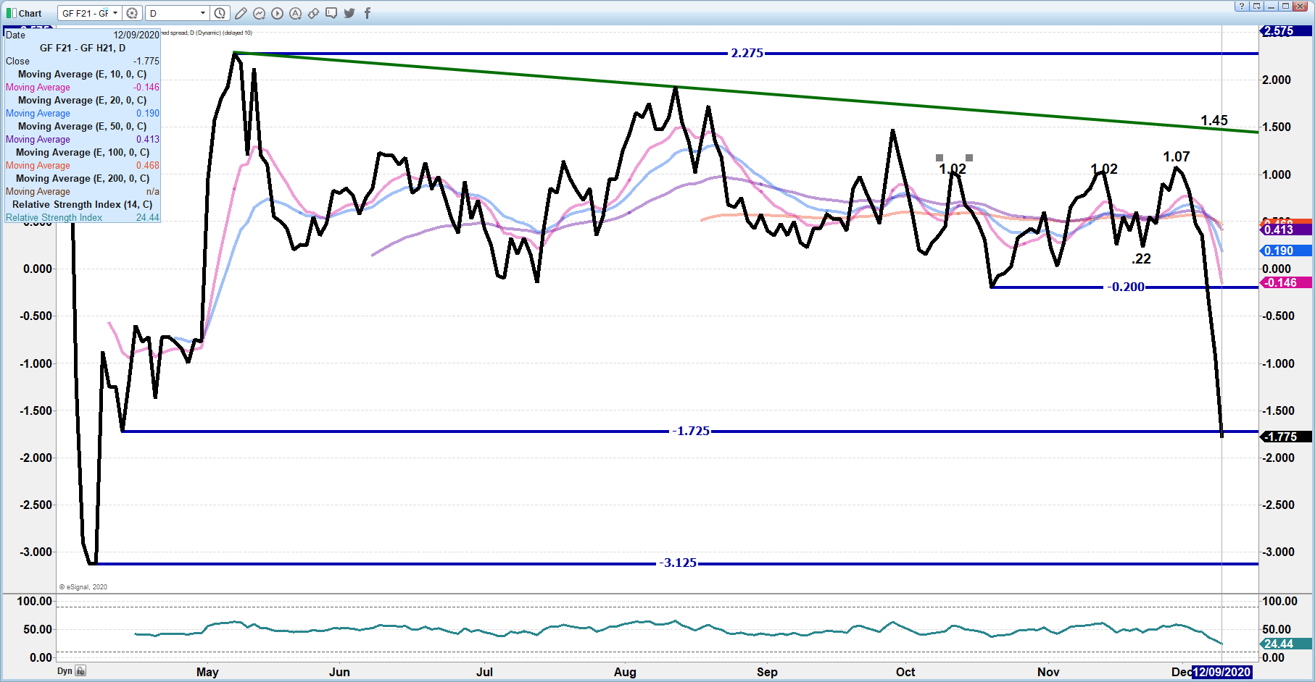
JANUARY 2021 FEEDER CATTLE – Needs to hold Wednesday low 136.57. Support 134.50 Resistance at 138.37
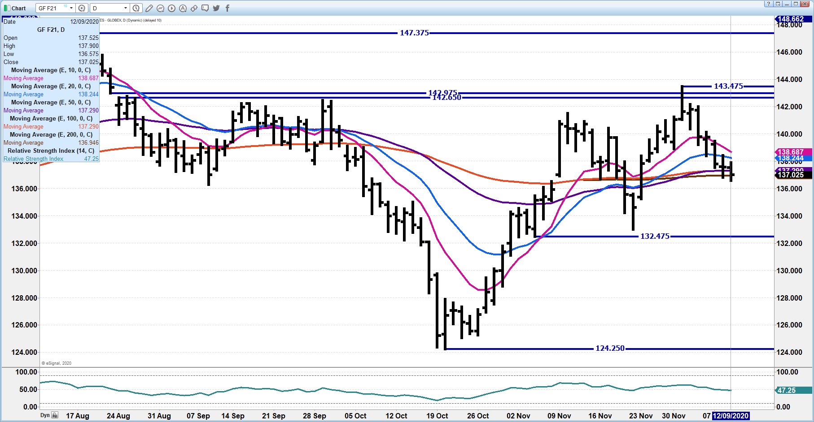

LEAN HOGS

USDA ESTIMATED FEDERAL HOG SLAUGHTER
DECEMBER 09, 2020 496,000
WEEK AGO 490,000
YEAR AGO 492,000
WEEK TO DATE (EST) 1,479,000
SAME PERIOD LAST WEEK (EST) 1,475,000
SAME PERIOD LAST YEAR (ACT ) 1,475,000

=========================
CME CASH HOG INDEX 12/05/2020 AT 65.60 down 19 cents FROM PREVIOUS DAY

CME CASH PORK CUTOUT INDEX 12/08/2020 AT 78.09 UP 19 CENTs FROM PREVIOUS DAY

CME CASH FRESH BACON INDEX ON 12/04/2020 WAS 126.66 COMPARED TO 11/27/2020 WAS 123.40

===================================
Ham and loins both down on Wednesday with loins breaking $70 and hams below $90. At this time of year it isn’t positive. If it wasn’t for Mexico hams and bellies would be much lower. Cheap dollar is benefit for Mexico.
=============================
2020 year to date hog slaughter is close to 1% above 2019. Packers seem to have worked out problems when employees are sick with extra employees trained to work several stations in the plant. Packers have increased the nursing staff in plants and processing facilities. Clinics are on site to work with employees when ill. More robotics are used. Some packers are testing for COVID 19 and some are temperature testing when employees come to work and spot testing throughout the day. Break time and when employees take time to eat have scheduled to allow more social distancing.

Packers and unions are pushing for employees to be near the top of the list when vaccinations become readily available because employees were not only considered “essential” workers but are working under the Defense Protection Act.

===============================
USDA MARKET NEWS
Based on negotiated prices and volume of pork cuts delivered within 14 days and on average industry cutting yields.
Calculations for 215 lb Pork Carcass. 55-56% lean, 0.55"-0.70" BF Last Rib

NATIONAL DAILY PORK REPORT FOB PLANT - NEGOTIATED SALES
DECEMBER 09, 2020
LOADS OF PORK CUTS: 260.34
LOADS TRIM/PROCESSED PORK: 39.96

FINAL
Date Loads Carcass Loin Butt Pic Rib Ham Belly
12/09/2020 300.30 77.60 69.03 67.49 59.49 133.09 87.35 92.61
CHANGE : -0.52 -0.75 -3.38 -1.80 -1.31 -2.77 3.22
Five Day Average -- 77.65 70.42 67.50 61.75 133.08 86.34 92.08

FINAL PREVIOUS WEEK’S CLOSE
Date Loads Carcass Loin Butt Pic Rib Ham Belly
12/04/2020 347.84 78.17 69.76 66.65 62.98 132.42 88.03 93.30
=============================
NATIONAL DAILY DIRECT HOG PRIOR DAY REPORT - SLAUGHTERED SWINE
Slaughter Data for DECEMBER 9, 2020
Average live weight - 288.44
Average carcass - 215.88
==========================
DAILY DIRECT HOGS PLANT DELIVERED AS OF 1:30 PM DECEMBER 9, 2020
NATIONAL NEGOTIATED PURCHASE BASE CARCASS PRICES
Carcass Base Price: $48.00 - $57.00
Weighted Average: $55.03
Change from Prior Day: 0.32 lower
HOGS SOLD: 7,455

SWINE OR PORK MARKET FORMULA PURCHASE (Including Packer Sold)
PRICE RANGE: $55.10 - $73.69
Weighted Average: $64.63
Previous Day: $64.16
HOGS SOLD: 155,999

https://www.ams.usda.gov/mnreports/lm_hg203.txt
June/April Lean Hog Spread – Spread remains wide with mostly specs trading April and June. 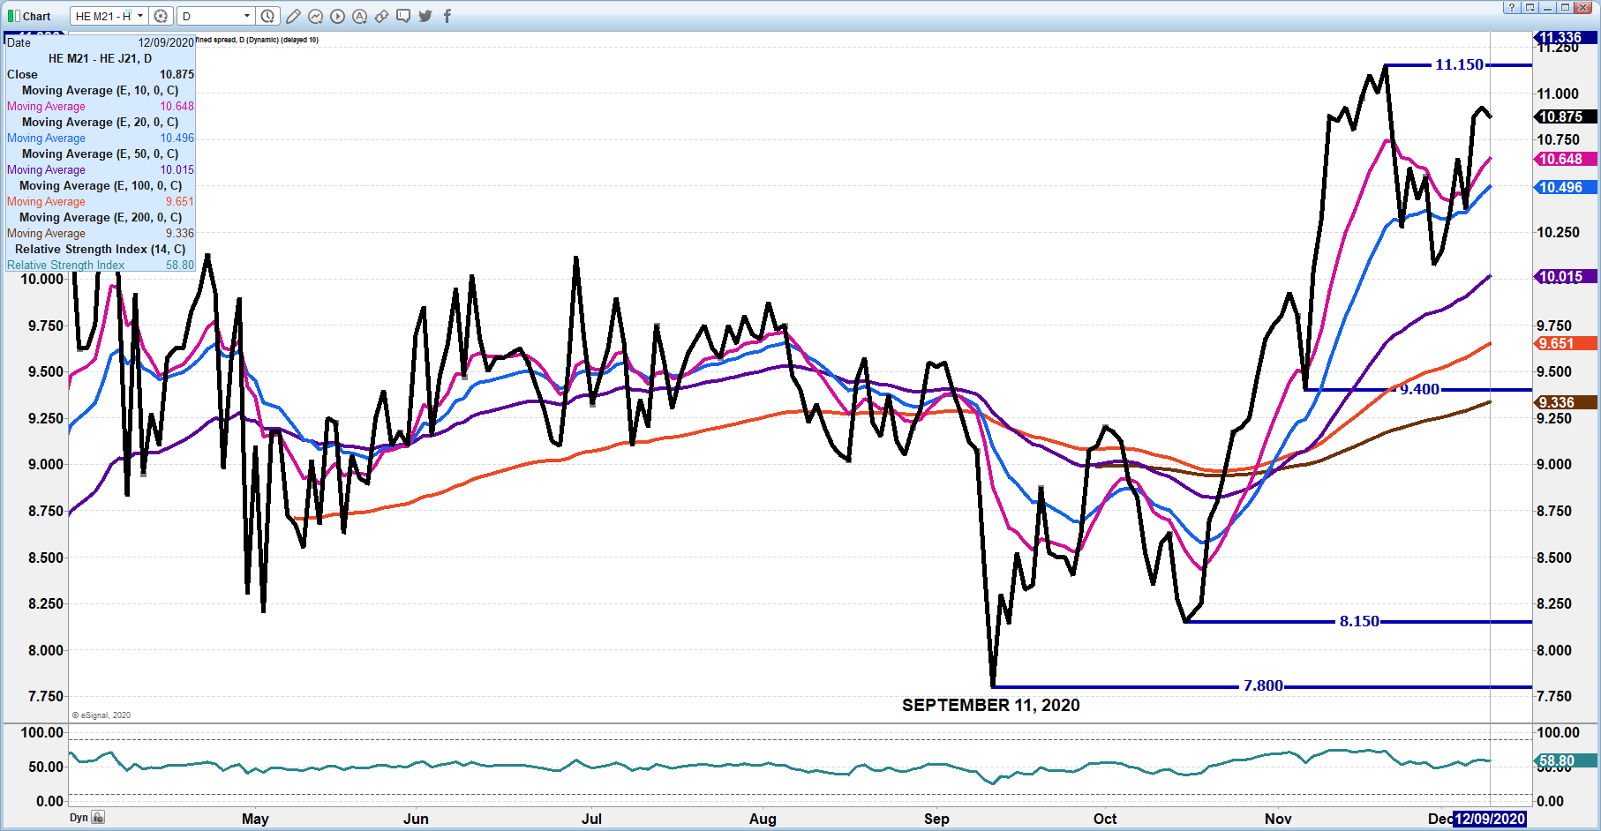
DeC 2020 LEAN HOGS – going nowhere Dec failry inline with CME Index
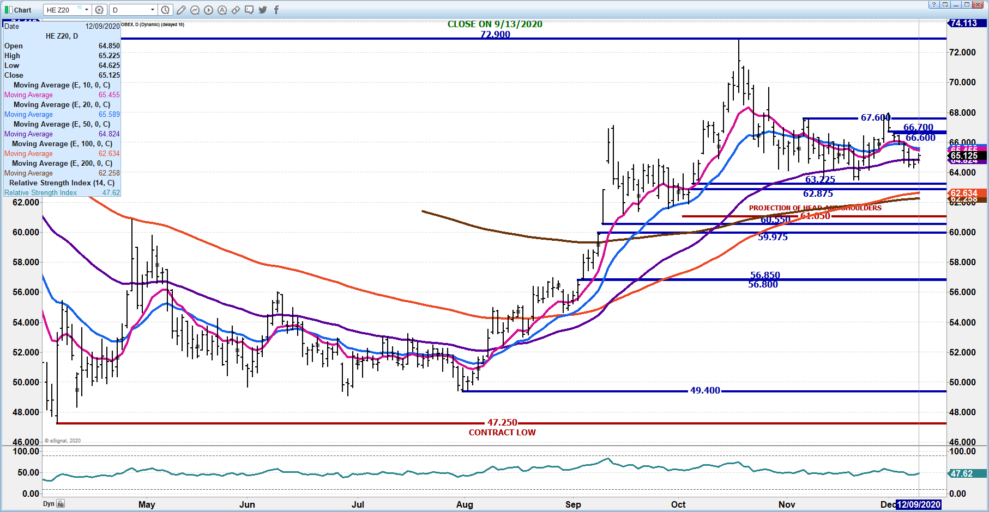
FEBRUARY 2021 LEAN HOGS – Volume 10,915 63.17 to 62.95 support Resistance at 66.37
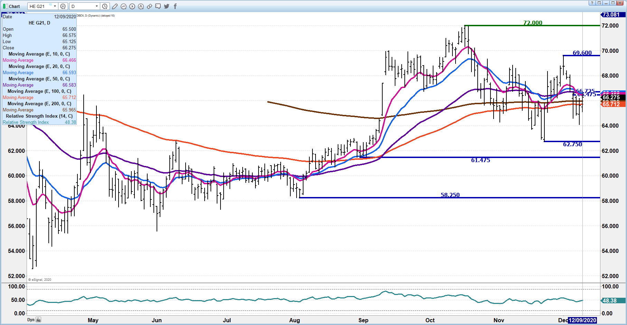
Beef: Net sales of 3,000 MT reported for 2020 were down 78 percent from the previous week and 80 percent from the prior 4-week average. Increases primarily for Japan (3,300 MT, including decreases of 400 MT), Mexico (1,700 MT, including decreases of 100 MT), Canada (1,300 MT), China (800 MT, including decreases of 300 MT), and Indonesia (400 MT), were offset by reductions primarily for South Korea (4,600 MT) and Hong Kong (1,000 MT). For 2021, net sales of 12,000 MT were primarily for South Korea (7,200 MT), Japan (1,600 MT), Hong Kong (1,200 MT), China (1,000 MT), and Mexico (900 MT). Exports of 18,200 MT were up 10 percent from the previous week, but unchanged from the prior 4-week average. The destinations were primarily to Japan (5,100 MT), South Korea (4,400 MT), Mexico (2,600 MT), China (1,800 MT), and Hong Kong (1,400 MT).

Pork: Net sales of 26,500 MT reported for 2020 were down 15 percent from the previous week and 13 percent from the prior 4-week average. Increases primarily for Mexico (10,400 MT, including decreases of 900 MT), China (6,300 MT, including decreases of 1,900 MT), Japan (5,500 MT, including decreases of 200 MT), South Korea (900 MT, including decreases of 1,200 MT), and Australia (900 MT, including decreases of 400 MT), were offset by reductions primarily for Nicaragua (200 MT). For 2021, net sales of 6,400 MT were primarily for South Korea (1,700 MT), Japan (1,200 MT), Colombia (900 MT), the Dominican Republic (700 MT), and China (500 MT). Exports of 42,000 MT were up 23 percent from the previous week and 11 percent from the prior 4-week average. The destinations were primarily to China (13,300 MT), Mexico (13,200 MT), Japan (5,200 MT), South Korea (3,100 MT), and Canada (2,200 MT).

CHARTS FROM ESIGNAL INTERACTIVE, INC.

