Daily Futures Market Commentary
Livestock Outlook

MONDAY MORNING april 24, 2023 LIVESTOCK REPORT
Chris Lehner, Senior Livestock Analyst | 312.242.7942 | chris.lehner@admis.com

CATTLE

Daily CATTLE Slaughter
april 21, 2023 108,000
WEEK AGO 112,000
YEAR AGO 120,000
SATURDAY 04/22/2023 12,000 A WEEK AGO 12,000, YEAR AGO 62,000
WEEK TO DATE (EST) 622,000
SAME PERIOD LAST WEEK (EST) 613,000
SAME PERIOD LAST YEAR (ACT) 644,000
2023 YEAR TO DATE 10,027,000
2022 YEAR TO DATE 10,352,000
YEAR TO DATE PERCENT CHANGE MINUS 3.1% PREVIOUS WEEK MINUS 2.9%

===========================================
BOXED BEEF 2:00 pm CHOICE SELECT
Current Cutout Values: 306.60 287.80
Change from prior day: (0.39) (0.94)
CHOICE/SELECT SPREAD: 18.80
Total Load Count (Cuts, Trimmings, Grinds) 104
5 Day Simple Average: 305.71 289.00
5 DAY SIMPLE AVERAGE: april 14, 2023 295.58 280.28

===================================
CME BOXED BEEF INDEX ON 04/20/2023 WAS 302.32 UP 1.28 FROM PREVIOUS DAY.
CME BOXED BEEF INDEX ON 04/13/2023 WAS 292.68
==================================
2:00 pM APRIL 21, 2023
PRIMAL RIB 477.76 399.92
PRIMAL CHUCK 242.93 241.70
PRIMAL ROUND 234.08 233.29
PRIMAL LOIN 427.46 384.93
PRIMAL BRISKET 243.81 238.90
PRIMAL SHORT PLATE 258.72 258.72
PRIMAL FLANK 197.43 194.60

2:00 pM APRIL 14, 2023 PREVIOUS WEEK
PRIMAL RIB 471.09 403.88
PRIMAL CHUCK 241.47 236.50
PRIMAL ROUND 232.17 231.25
PRIMAL LOIN 422.76 381.05
PRIMAL BRISKET 238.15 232.00
PRIMAL SHORT PLATE 247.81 247.81
PRIMAL FLANK 188.42 181.14
===========================

LOAD COUNT AND CUTOUT VALUE SUMMARY
Date Choice Select Trim Grinds Total 600-900 600-900
04/20 68 18 4 10 100 306.99 288.74
04/19 61 27 7 10 106 305.92 291.46
04/18 74 21 8 22 124 307.06 291.61
04/17 52 15 8 19 95 305.98 289.32
04/14 59 7 8 7 80 FRIDAY 302.62 283.87 FRIDAY
=====================================
National Boxed Beef Cuts - Negotiated Sales
FOB Plant basis negotiated sales for delivery within 0-21 day period. Prior days sales after 1:30pm are included.

Choice Cuts 77.62 loads 3,104,798 pounds
Select Cuts 15.01 loads 600,410 pounds
Trimmings 5.61 loads 224,423 pounds
Ground Beef 5.89 loads 235,439 pounds
====================================
APRIL 2023 LIVE CATTLE DELIVERIES

DELIVERY NOTICE SERVED – APRIL 2023 - LIVE CATTLE
DATE O4/21/23 SETTLEMENT: $173.97
OLDEST LONG – 01/03/23 $160.87

0 DELIVERIES
FIRM # FIRM NAME DEL REC
YARD LOCATION

===================================
USDA LIVESTOCK REPORTS FOR APRIL 2023
COLD STORAGE REPORT TUESDAY APRIL 25, 2023 2:00pm CENTRAL TIME

======================================
CATTLE ON FEED REPORT
APRIL 21, 2023

Range Average Actual Mln head Mln Est
On feed April 1 94.4-95.5 95 96 11.6 11.5
Placements in March 91.5-99 94.8 99 99 1.887
Marketings in March 97.2-100 99.1 99 1.98 1.982

United States Cattle on Feed Down 4 Percent

Cattle and calves on feed for the slaughter market in the United States for feedlots with capacity of 1,000 or more head totaled 11.6 million head on April 1, 2023. The inventory was 4 percent below April 1, 2022. The inventory included 7.12 million steers and steer calves, down 6 percent from the previous year. This group accounted for 61 percent of the total inventory. Heifers and heifer calves accounted for 4.50 million head, down 2 percent from 2022.

Placements in feedlots during March totaled 1.99 million head, 1 percent below 2022. Net placements were 1.94 million head. During March, placements of cattle and calves weighing less than 600 pounds were 390,000 head, 600-699 pounds were 310,000 head, 700-799 pounds were 540,000 head, 800-899 pounds were 517,000 head, 900-999 pounds were 175,000 head, and 1,000 pounds and greater were 60,000 head.

Marketings of fed cattle during March totaled 1.98 million head, 1 percent below 2022.

Other disappearance totaled 53,000 head during March, unchanged from 2022.

=====================
It is possible traders could be disappointed that placements were more than anticipated especially in Texas up 5% and Nebraska unchanged. On the other side of the coin Kansas was down 5% with Iowa down just 1 percent.

================================

APRIL LIVE CATTLE ON APRIL 21,2023 CLOSED AT $173.97. THE 5 DAY NEGOTIATED AVERAGE PRICE IS $179.63.

By Friday, packers were essentially done buying cash cattle and were not at all aggressive dropping top prices by $2.00.

Federal kill was 622,000 head for the week. It was up 9,000 head from a week ago, but it is still considered a light kill. Packers pushed cattle through the line Monday through Thursday but backed down for Friday’s and Saturday’s kill.
=======================

Beef exports for week ending April 13, 2023 were 19,100MT, the best over the past 5 weeks. There are no big buyers and China who was a good buyer in 2022 has been backing off US exports. South Korea was the largest buyer taking 5,500 MT, Japan took 4,200 MT followed by Mexico at 2,800MT China took 2,100MT

Week Ending April 6, 2023 8,700MT
Week ending March 30, 2023 13,500MT
Week ending March 23, 2023 11,300MT
Week ending March 16, 2023 beef net sales were 18,600 MT.

5 week average 14,200MT
===================================

National Weekly Fed Cattle Comprehensive Report April 18, 2023

As of April 18, 2023 dressed steer and heifer carcasses averaged 859.9 pounds down 1 pound from previous week at 860.9 pounds and 14.7 pounds less than a year ago. The grading percent as of 4/18/23 was 83.5% compared to previous week at 83.6%.

As of April 19, 2022 dressed steer and heifer carcasses averaged 874.6 pounds. The grading percent was 82.5% .
https://www.ams.usda.gov/mnreports/ams_2700.pdf

=========================

***National Daily Direct Cattle 04/20/23
5 day accumulated weighted avg
Weight Price Head
Live Steer: 1452 $178.72 30,831
Live Heifer: 1326 $178.21 12,027
Dressed Steer 920 $288.24 13,352
Dressed Heifer: 801 $288.01 4,581

PREVIOUS WEEK
***NATIONAL DAILY DIRECT CATTLE 04/14/23
5 DAY ACCUMULATED WEIGHTED AVG
WEIGHT PRICE HEAD
LIVE STEER: 1450 $180.08 33,908
LIVE HEIFER: 1319 $179.20 17,961
DRESSED STEER 925 $289.42 17,260
DRESSED HEIFER: 810 $289.42 5,417

=======================

USDA POSTED SUMMARY CATTLE PRICES ON 04/20/2023

IA/MN – cash – 173.00 - 182.00 average price $180.34
dreSSED – 284.00 - 285.00 average PRICE $284.64

NE – cash – 182.00 on 38 fob steers
dressed – 280.00 - 284.00 AVERAGE PRICE 282.40 on 192 head

KS – CASH – 174.00 on 472 head
dressed - 274.00 on 1077 head

TX/OK/NM no cattle bought Friday
cash – 173.00 - 174.00 AVERAGE PRICE 173.94
dressed – No Reportable Trade.

CO - **Not reported due to Confidentiality**

===================================

National Weekly Direct Beef Type Price Distribution
USDA weighted average price
https://mymarketnews.ams.usda.gov/viewReport/3492

====================================

June LIVE CATTLE/june LEAN HOG SPREAD - CATTLE SHOULD REMAIN GAINING ON HOGS
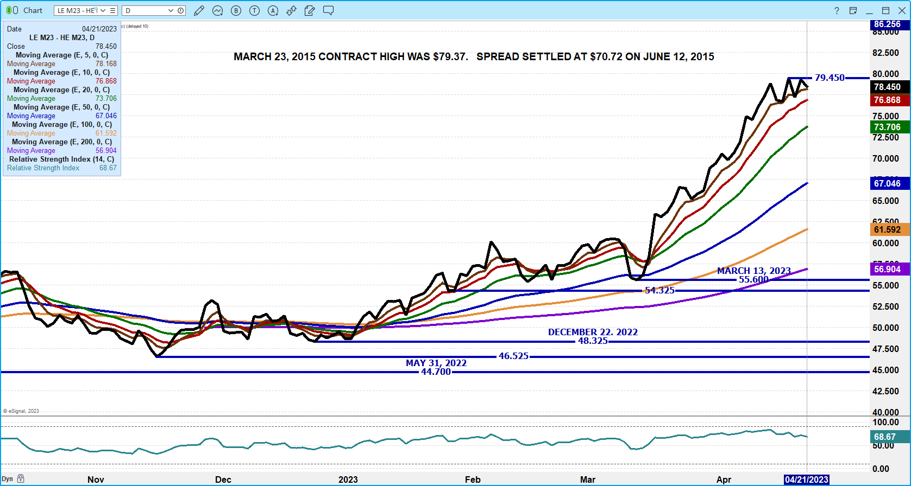
JUNE LIVE CATTLE /AUGUST LIVE CATTLE SPREAD - BULL SPREAD SHOULD CONTINUE
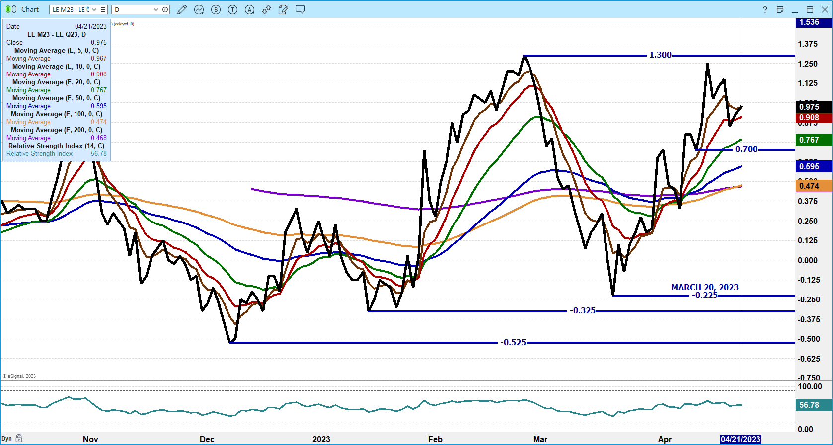

AUGUST LIVE CATTLE/OCTOBER LIVE CATTLE SPREAD – LOOK FOR AUGUST TO GAIN ON OCTOBER
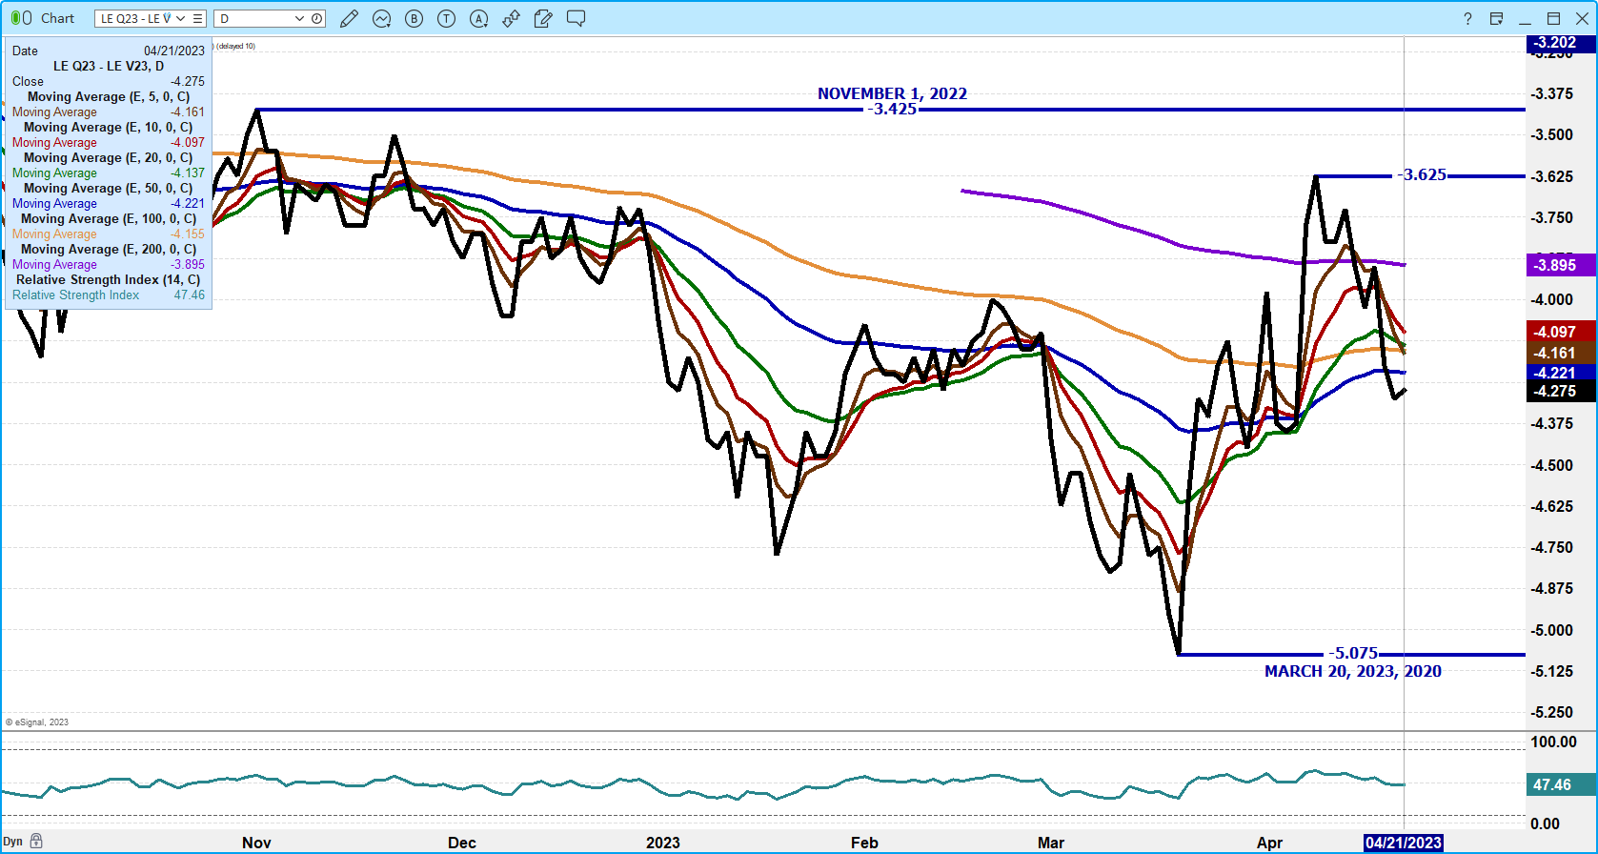

APRIL 2023 LIVE CATTLE – VOLUME AT 1563 OPEN INTEREST AT 2574
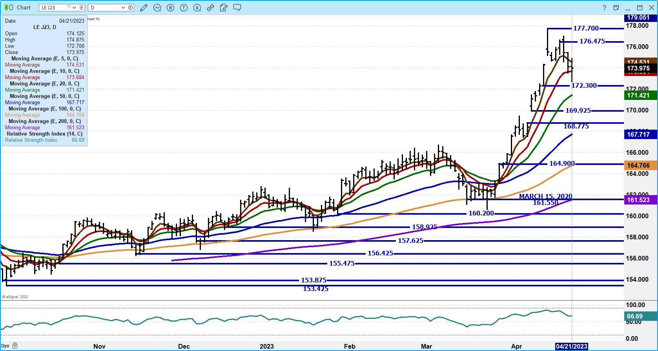

june 2023 live cattle – RESISTANCE AT 166.27 TO 1.68.50 SUPPORT AT 163.83 TO 162.60 VOLUME AT 17,431
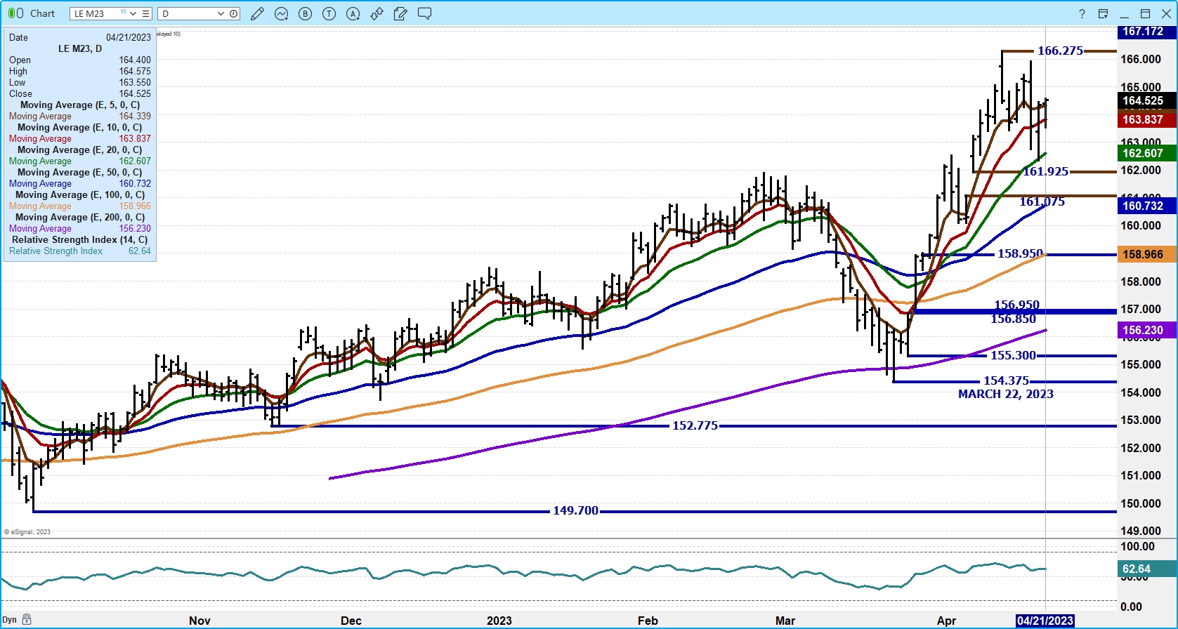
december 2023 LIVE CATTLE – VOLUME AT 3432 RESISTANCE AT 172.90 TO 174.87 SUPPORT AT 171.55 TO 170.60
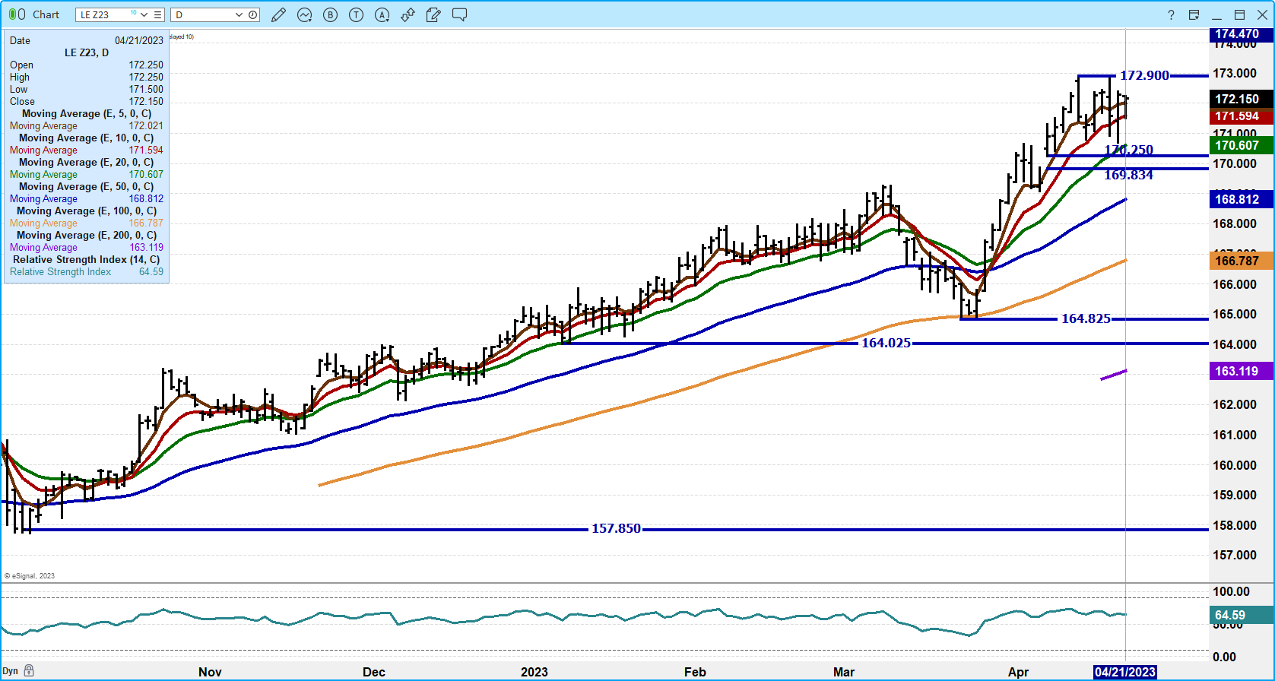

FEEDER CATTLE

CME FEEDER INDEX ON 04/19/2023 waS 203.10 DOWN 81 cents from previous day –

april 2023 feeder cattle futures settled on 04/21/2023 at $203.77

===============================
cof REPORT WITH PLACEMENTS DOWN JUST 6 PERCENT LIKELY WILL CHANGE BEAR SPREADS AND FOR EXAMPLE, TAKE AWAY PREMIUM ON aUGUST OVER mAY.
===================

MAY 2023 FEEDER CATTLE/AUGUST 2023 FEEDER CATTLE SPREAD – BEAR SPREAD REPORT COULD REVERSE SPREAD
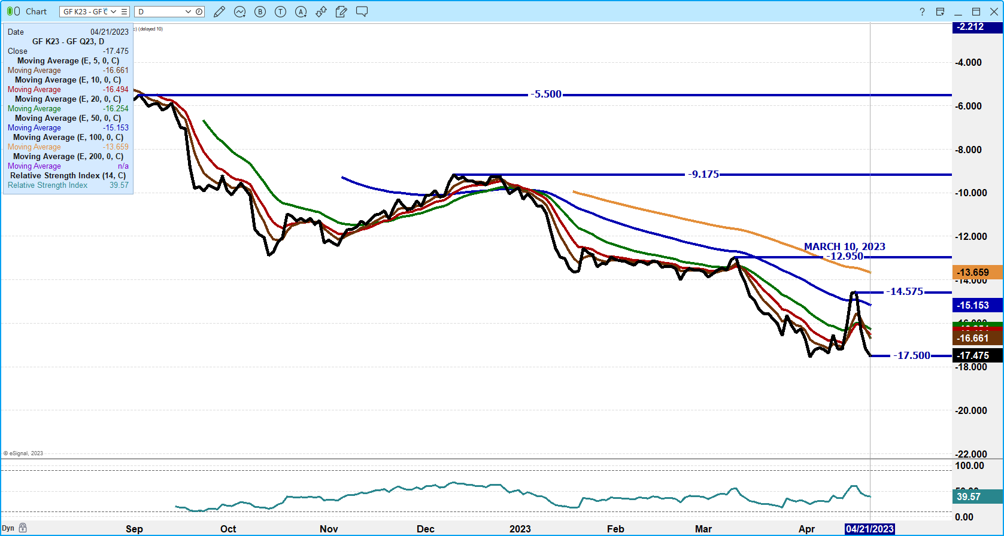

MAY 2023 FEEDER CATTLE – RESISTANCE AT 212.77 SUPPORT 209.55 TO 207.00
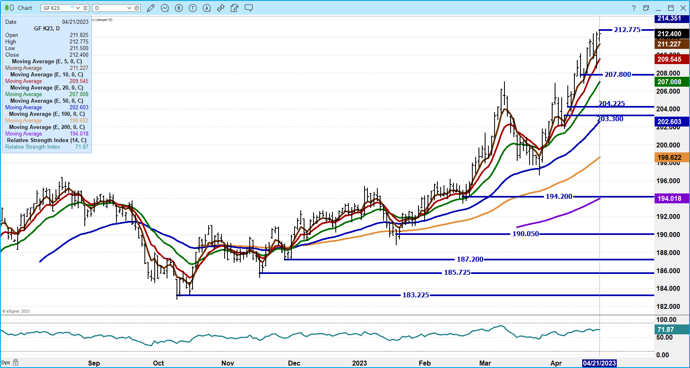
AUGUST 2023 FEEDER CATTLE – RESISTANCE AT 230.27 SUPPORT AT 226.00 TO 217.75
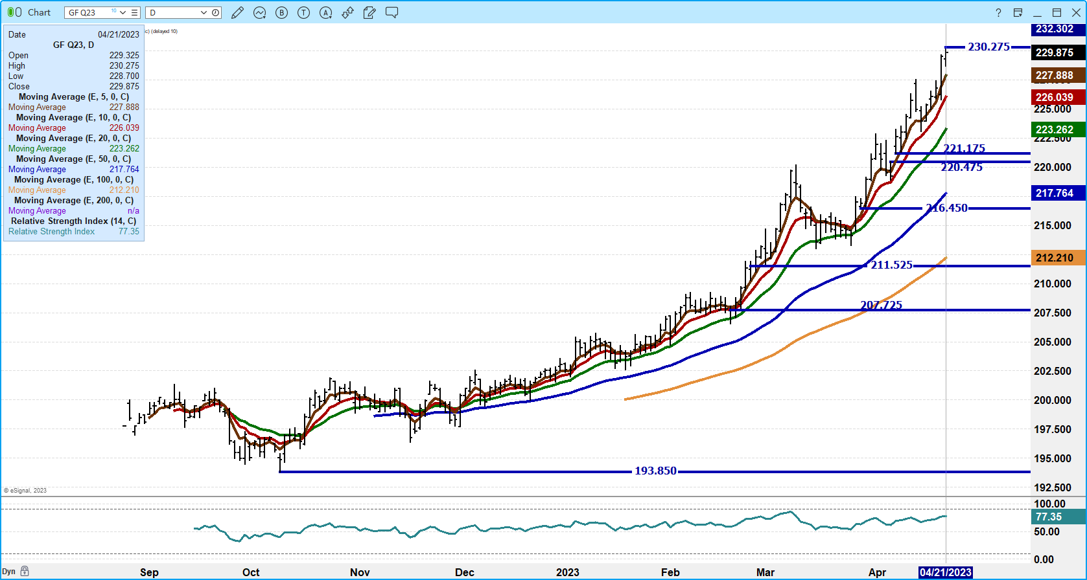

NOV FEEDER CATTLE – NEW CONTRACT HIGH RESISTANCE AT 234.05 SUPPORT AT 232.00 TO 223.60
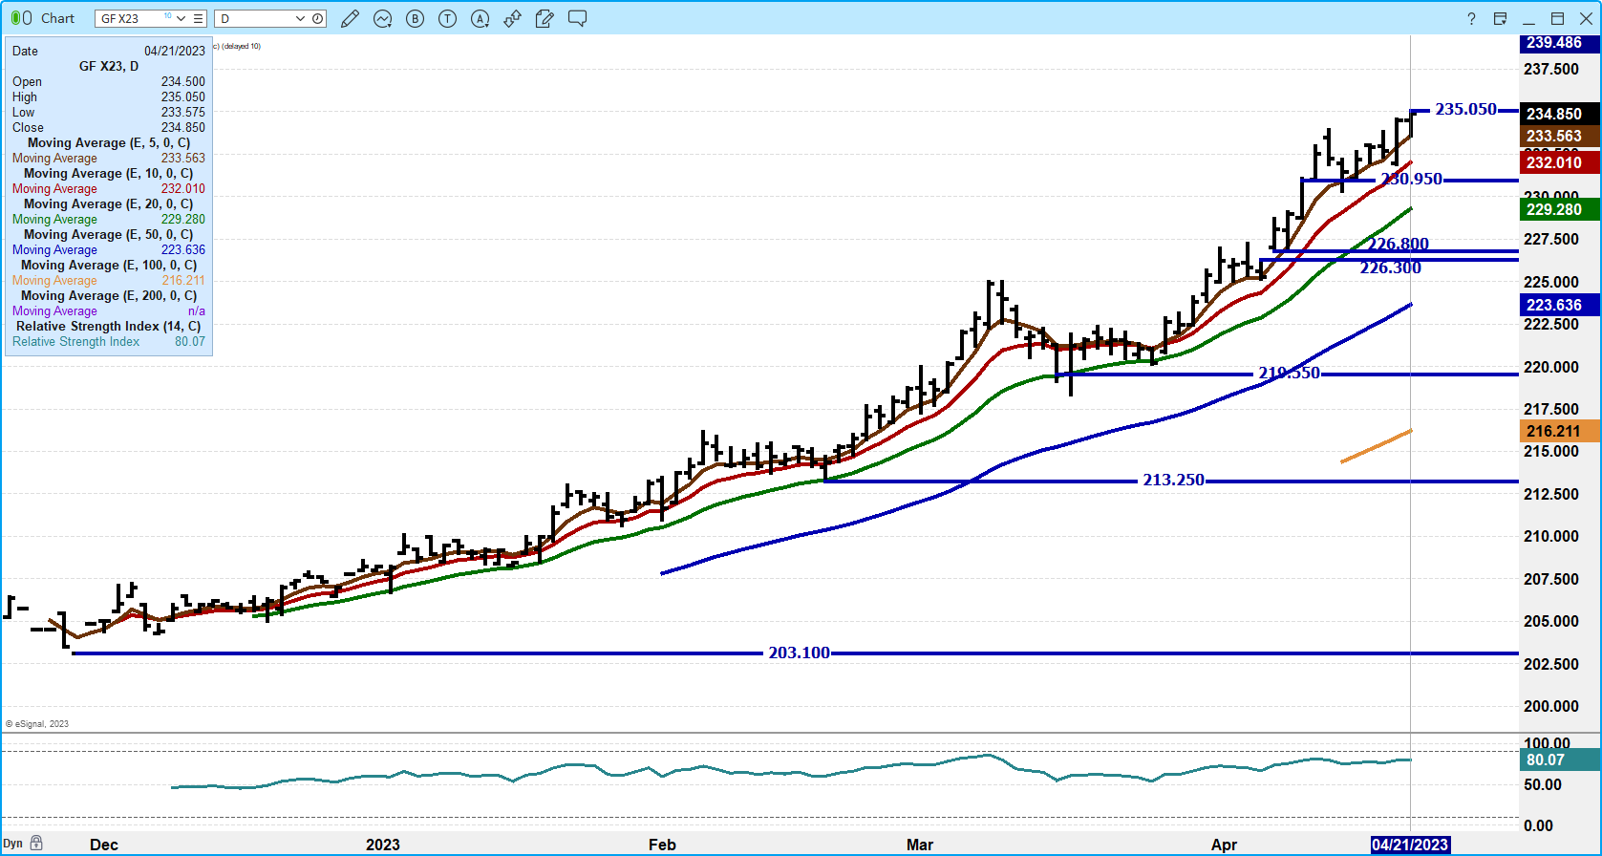

============================================

HOGS

USDA ESTIMATED FEDERAL HOG SLAUGHTER
APRIL 21, 2023 469,000
WEEK AGO 466,000
YEAR AGO 460,000
SATURDAY 04/22/2023 85,000 - A WEEK AGO 173,000 - YEAR AGO 115,000
WEEK TO DATE (EST) 2,459,000
SAME PERIOD LAST WEEK (EST) 2,429,000
SAME PERIOD LAST YEAR (ACT) 2,376,000
2023 YEAR TO DATE 39,776,000
2022 *YEAR TO DATE 39,126,000
YEAR TO DATE PERCENT CHANGE PLUS 1.7% PREVIOUS WEEK 1.6%

=======================================

CME LEAN HOG INDEX ON 04/19/2023 WAS $71.41 down 16 CENTS FROM PREVIOUS DAY
CME LEAN HOG INDEX ON 04/12/2023 WAS $71.95

CME PORK CUTOUT INDEX 04/20/2023 AT $77.98 up 11 CENTS FROM PREVIOUS DAY
CME PORK CUTOUT INDEX 04/13/2023 AT $77.14

THE CME LEAN HOG INDEX IS MINUS $6.46 TO THE CME PORK INDEX.
THE CME LEAN HOG INDEX IS MINUS $5.19 TO THE CME PORK INDEX.

=================================================
For the week there was an uptick on the daily pork carcass price. The gains were due to higher prices for Butts and Bellies. What pork needs is to have Loins and Hams move higher or to have substantial large gains on Butts, Picnics, Ribs and Bellies. It is hard to rally pork with cheap loins and hams.
========================================
Exports this year are a gift for US pork producers. Exports are good because Mexico is buying a lot of pork to lower food inflation.
Pork exports picked up last week for week ending April 13, 2023. Net export sales were 36,100MT with Mexico taking 13,100MT, Japan 4,600MT followed by Australia with 4,200MT China didn’t buy

PORK EXPORTS

WEEK ENDING APRIL 6, 2023 NET EXPORT SALES WERE 27,100 MT
WEEK ENDING MARCH 30, 2023 NET EXPORT SALES WERE 53,200 MT
WEEK ENDING MARCH 23, 2023 NET EXPORT SALES WERE 30,400 MT
WEEK ENDING MARCH 16, 2023 NET EXPORT SALES WERE 38,000 MT

5 week average 36,960MT
===========================================

PORK REPORT FOB PLANT - NEGOTIATED SALES
Based on negotiated prices and volume of pork cuts delivered within 14 days and on average industry cutting yields. Calculations for 215 lb. Pork Carcass. 55-56% lean, 0.55"-0.70" BF Last Rib

Loads PORK CUTS : 211.87
Loads TRIM/PROCESS PORK : 35.89

2:00 pM LOADS CARCASS LOIN BUTT PIC RIB HAM BELLY
04/21/2023 247.76 80.43 80.84 110.37 62.90 112.78 75.51 87.27
CHANGE: 2.28 0.06 2.15 -0.23 1.99 5.22 5.24
FIVE DAY AVERAGE -- 78.39 80.55 106.51 63.74 112.24 71.69 82.44

PREVIOUS WEEK FRIDAY PRICES
2:00 pM LOADS CARCASS LOIN BUTT PIC RIB HAM BELLY
04/14/2023 258.75 78.25 81.07 103.08 65.94 110.17 76.33 75.16
CHANGE: 0.69 1.41 -2.45 0.33 1.74 2.64 -0.25
FIVE DAY AVERAGE -- 77.27 80.94 103.16 65.92 113.62 71.06 75.63
=====================================

Daily Direct Afternoon Hog Report - Plant Delivered Purchase
APRIL 21, 2023
https://www.ams.usda.gov/sites/default/files/media/LMRSwineReportingHandout.pdf

National Negotiated Carcass Price
Head Count: 4,165
Lowest price: 60.00
Highest price: 70.00
Weighted Average 66.02
Change from Previous Day -0.90 lower

National Negotiated Carcass Price APRIL 14, 2023
Head Count: 4,982
Lowest price: 62.00
Highest price: 72.00
Weighted Average 68.96
Change from Previous Day -0.30 lower

Other Market Formula (Carcass)
Head Count: 19,472
Lowest Base Price: 70.36
Highest Base Price: 100.35
Weighted Average Price: 79.25

Swine/Pork Market Formula (Carcass)
Head Count 146,658
Lowest base price: 58.52
Highest Base Price: 77.87
Weighted Average Price 69.41

Other Purchase Arrangement (Carcass)
HEAD COUNT: 64,509
Lowest base price: 66.57
Highest base price: 110.05
Weighted Average Price: 78.49
=========================

NATIONAL DAILY DIRECT HOG PRIOR DAY REPORT - SLAUGHTERED SWINE
https://www.ams.usda.gov/mnreports/ams_2511.pdf
SLAUGHTER DATA FOR April 20, 2023

**PRODUCER SOLD:
HEAD COUNT 237,912
AVERAGE LIVE WEIGHT 284.34
AVERAGE CARCASS WEIGHT 213.58
PACKER SOLD:
HEAD COUNT 30,906
AVERAGE LIVE WEIGHT 296.04
AVERAGE CARCASS WEIGHT 222.68
PACKER OWNED:
HEAD COUNT 176,919
AVERAGE LIVE WEIGHT 296.31
AVERAGE CARCASS WEIGHT 223.93
==========================

junE/august lean hog spread – bear spread.
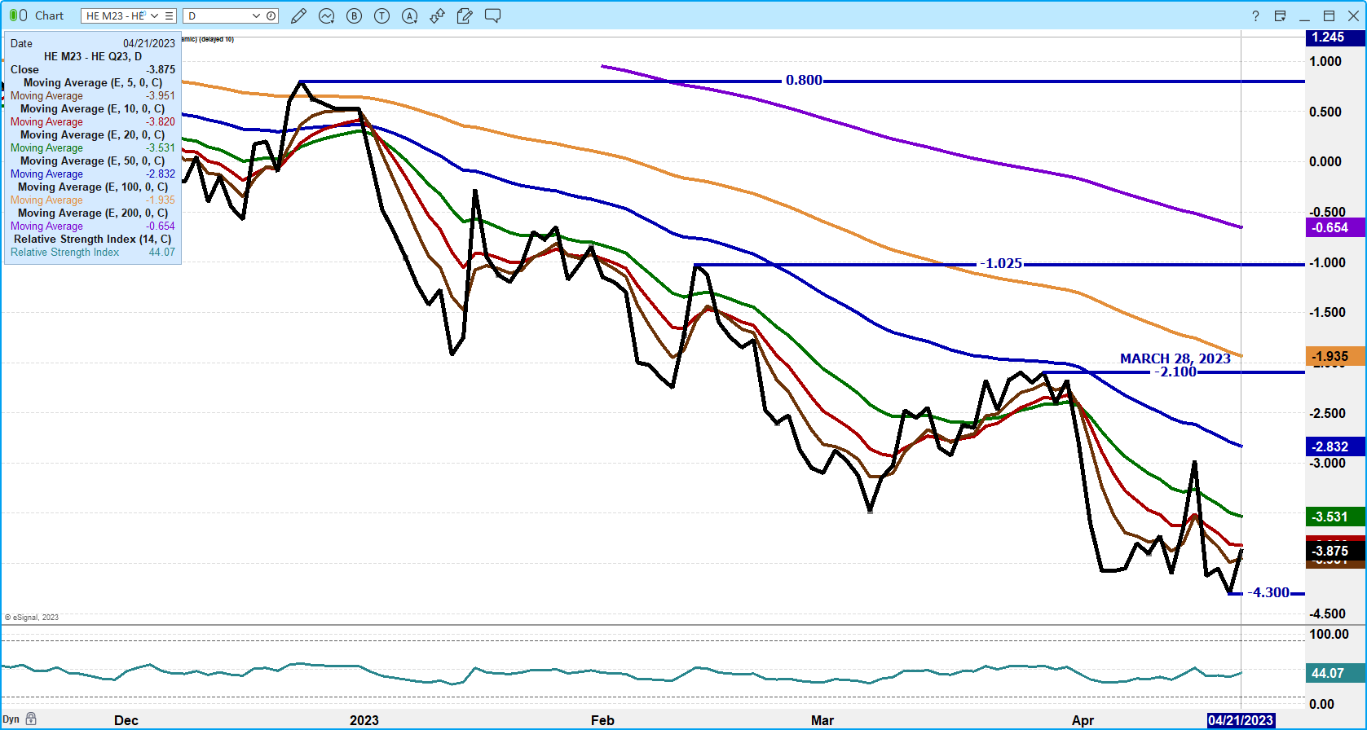

AUGUST/OCTOBER 2023 LEAN HOG SPREAD – spread narrowing is bearish
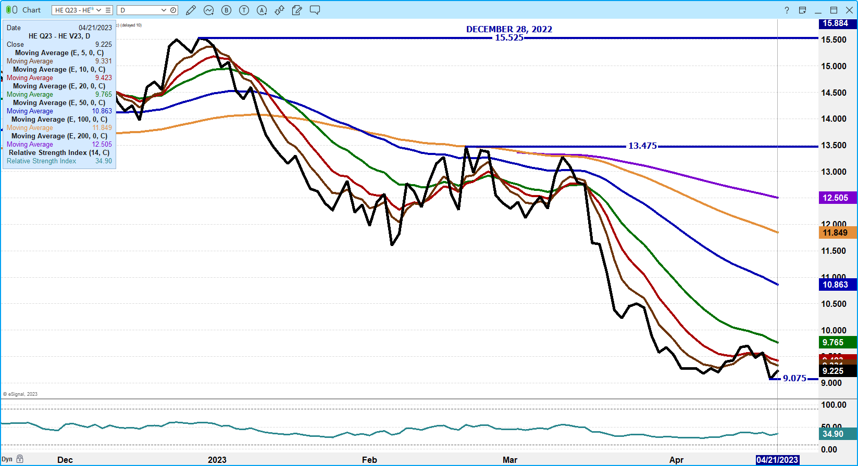
JUNE 2023 LEAN HOGS - volume was light at 15,615 new contract low made friday. support at 84.62 t0 81.65 resistance at 86.97 to 88.90
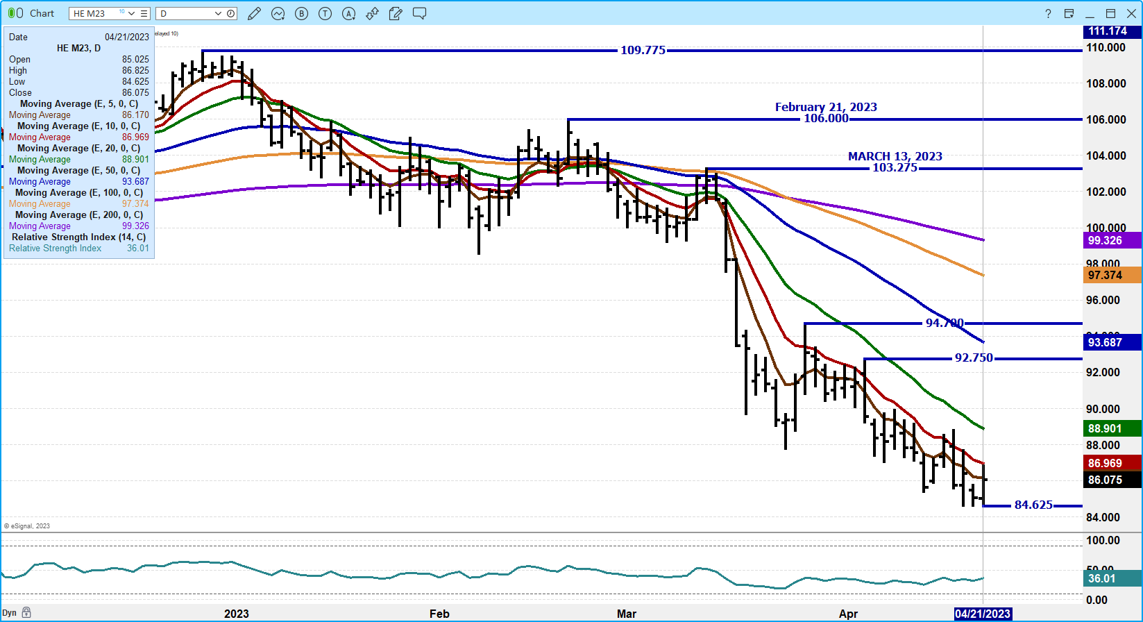

ocTOBER 2023 LEAN HOGS – volume at 2965 support at 79.95 to 77.87 resistance at 81.40 to 82.70
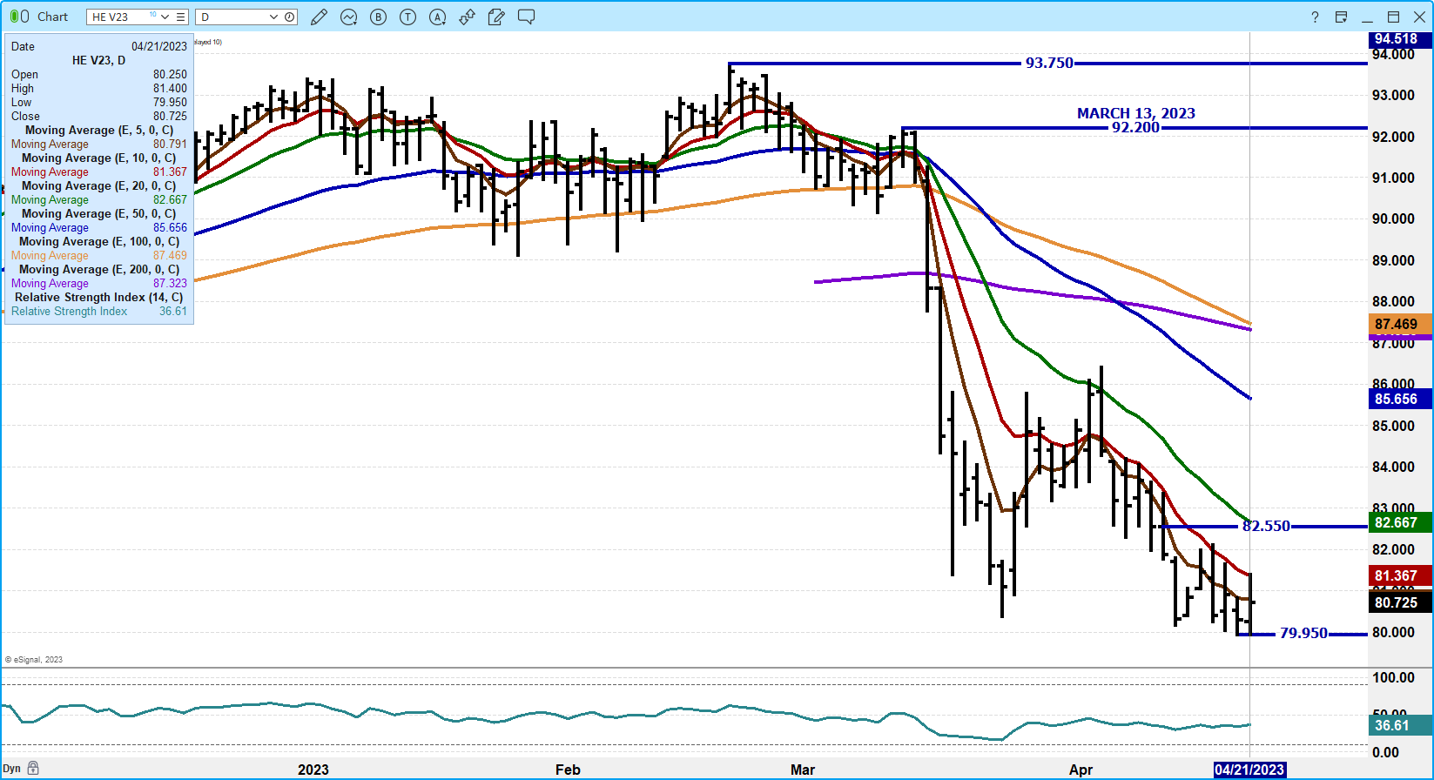

CHARTS FROM ESIGNAL INTERACTIVE, INC.

=====================================

Christopher Lehner
chris.lehner@admis.com 312 242 7942 913.787.6804

